Steps for Adding Someone as a Provider Into the Controlled Substance Log AdUsers Table

1. Check for the person in Active Directory.
   1. Press Windows “Start” button and enter “Active Directory” without quotes.
   2. When the Active Directory appears, open it.
   3. Highlight and then right-click on the ad.sumg.int, then click on the “Find…” context menu item.
   4. Enter the last name of the Provider and press the “Find New” button.

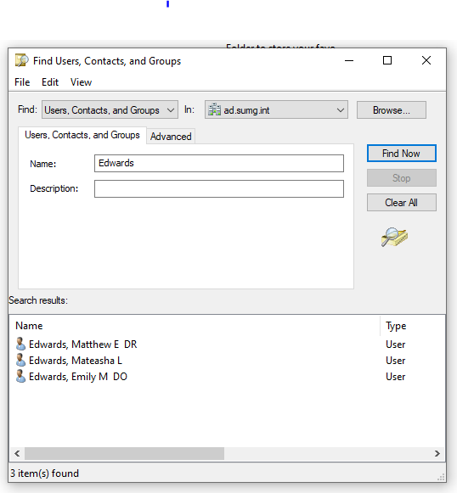

* 1. If the person you would like to add is not in the list, contact IT Architects.
  2. If the person is in the list, double-click their name to bring up their entire Active Directory entry.
  3. Highlight the “Display Name” value and press the Ctrl+C key sequence to copy the value to the system clipboard.
  4. Open SQL Server Management Studio and navigate to the
     1. SQL Server Instance: appdb01
     2. Database: ControlledSubstanceLog
     3. Table: AdUsers
  5. Right-click on the AdUsers table and select the “Script Table as -> Insert To -> New Query Window” context menu option to bring up the “Insert INTO” statement for the table.

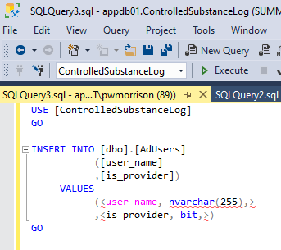

* 1. Replace the “<user_name, nvarchar(255),>” with a pair of single quotes, then place the cursor between the pair of single quotes and press the Ctrl+V to paste the Active Directory Display Name value from the system clipboard to the single-quoted text.

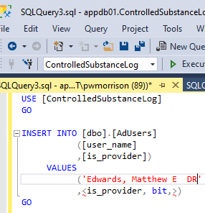

* 1. Replace the “<is_provider, bit,>” text with “1” to indicate that the person is a provider.

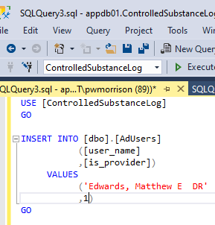

* 1. Press the “play” button to execute the Insert statement.